University of the People

MATH 1211 Calculus 1

Unit 3 Written Assignment

Anonymous Student

1. Use limit definition to find [ f'(2) ](https://my.uopeople.edu/filter/tex/displaytex.php?texexp=%20f%27%282%29%20) for the function, [f(x)=3x^2-4x+1](https://my.uopeople.edu/filter/tex/displaytex.php?texexp=f%28x%29%3D3x%5E2-4x%2B1). Show detailed work for credit.

According to the limit definition of derivative the prime of

f^-1 (2) = $\lim_{x→2} ({f(x)-f(a))/(x-2)}$

= (3x^2-4x+1 – (3\*4-8+1)) / (x-2)

= 3x2 -4x - 4 /(x-2) = (3x+2)(x-2)/(x-2) = 3x+2 = 8

2. A coffee shop determines that the daily profit on scones obtained by charging [ s ](https://my.uopeople.edu/filter/tex/displaytex.php?texexp=%20s%20) dollars per scone is [ P(s) = -20s^2 + 150s - 10 ](https://my.uopeople.edu/filter/tex/displaytex.php?texexp=%20P%28s%29%20%3D%20-20s%5E2%20%2B%20150s%20-%2010%20). The coffee shop currently charges $3.25 per scone. Find [ P'(3.25) ](https://my.uopeople.edu/filter/tex/displaytex.php?texexp=%20P%27%283.25%29%20), the rate of change of profit when the price is $3.25, explain what it means, and decide whether or not the coffee shop should consider raising or lowering its prices on scones. Show detailed work for credit.

P(3.25) = -20(3.25)2 +150s -10 = 266.25 dollors

P(x) > 0

According to the product and sum rule (*3.3 Differentiation Rules - Calculus Volume 1 | OpenStax*, n.d.),

P’(3.25) = -20\*2s +150 =20.

As P(3.25)>0 P’(3.25) >0, the coffee shop should increase the price to gain better profit.

3. Use Desmos to graph a cubic polynomial function, [f(x)](https://my.uopeople.edu/filter/tex/displaytex.php?texexp=f%28x%29) of your choice and it’s derivative, [f'(x)](https://my.uopeople.edu/filter/tex/displaytex.php?texexp=f%27%28x%29) and explain the changes that happened. For example, if [ x=a ](https://my.uopeople.edu/filter/tex/displaytex.php?texexp=%20x%3Da%20) is where [f(x)](https://my.uopeople.edu/filter/tex/displaytex.php?texexp=f%28x%29) has an extreme value (max or min) then what happened to [f'(x)](https://my.uopeople.edu/filter/tex/displaytex.php?texexp=f%27%28x%29) at [ x=a ](https://my.uopeople.edu/filter/tex/displaytex.php?texexp=%20x%3Da%20). Explain the following:

* If [f(x)](https://my.uopeople.edu/filter/tex/displaytex.php?texexp=f%28x%29) is increasing or decreasing in an interval then what happens to [f'(x)](https://my.uopeople.edu/filter/tex/displaytex.php?texexp=f%27%28x%29) in those intervals?
* Is[f'(x)](https://my.uopeople.edu/filter/tex/displaytex.php?texexp=f%27%28x%29) above or below the x-axis, and why?

Then repeat with the graph a polynomial function, **[f(x)](https://my.uopeople.edu/filter/tex/displaytex.php?texexp=f%28x%29)** of degree 4 and repeat the same exercises. Show your work in full for maximum credit.

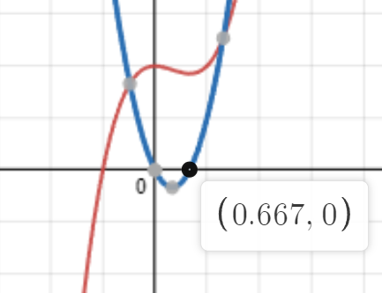

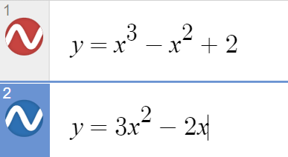

F(x) is

increseing over (-∞,0] , f’x having a positive value and decreses when the fx reaching maximum. f’x become 0 when there is a maximum or minimium.

decesing over [0,0.667) , f’(x) is less than 0

increasing over [0.667, ∞) f’(x) is increasing as the fx increses.

F’(x) is above x axis when the function increasing and below x axis when function decresing.

For degree 4,

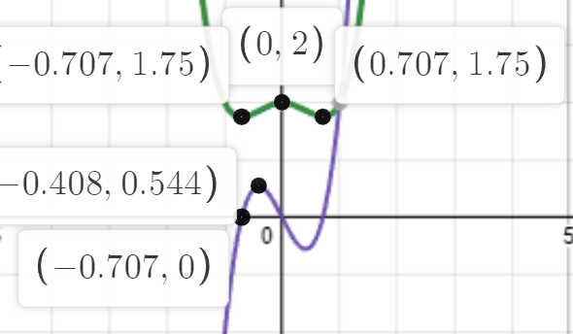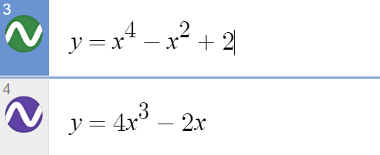

F(x) is

decesing over (-∞,-0.707] , f’x having a positive value and decreses when the fx reaching maximum. f’x become 0 when there is a maximum or minimium.

Fx increasing over [-0.707,0) , f’(x) is > 0

Fx decresing over [0, 0.707) f’(x) is decresing as the fx increses

Fx increasing over [0. 707, ∞) f’(x) is increasing as the fx increses.

F’(x) is above x axis when the function increasing and below x axis when function decresing.

4. For the following exercises, the given limit represents the derivative of a function [y = f (x) ](https://my.uopeople.edu/filter/tex/displaytex.php?texexp=y%20%3D%20f%20%28x%29%20) at [ x=a](https://my.uopeople.edu/filter/tex/displaytex.php?texexp=%20x%3Da). Find [f (x)](https://my.uopeople.edu/filter/tex/displaytex.php?texexp=f%20%28x%29) and [a](https://my.uopeople.edu/filter/tex/displaytex.php?texexp=a).

i)  [ \displaystyle \lim_{h \to 0} \frac{(1+h)^{2/3}-1}{h} ](https://my.uopeople.edu/filter/tex/displaytex.php?texexp=%20%5Cdisplaystyle%20%5Clim_%7Bh%20%5Cto%200%7D%20%5Cfrac%7B%281%2Bh%29%5E%7B2%2F3%7D-1%7D%7Bh%7D%20)  
ii)   [ \displaystyle \lim_{h \to 0} \frac{(2+h)^4-16}{h} ](https://my.uopeople.edu/filter/tex/displaytex.php?texexp=%20%5Cdisplaystyle%20%5Clim_%7Bh%20%5Cto%200%7D%20%5Cfrac%7B%282%2Bh%29%5E4-16%7D%7Bh%7D%20) 

1)

as f’(x) =

this formula is equivalent to

(f(a+h)2/3 -f(a) 2/3)/h

= (1+h) 2/3-12/3/ h

The function is f(x)=x2/3 the a = 1

2) similarly,

as f’(x) =

limit = (2+h)4 -24 /h

then its matching the bacis forms.

F(x)=x4 , and a =2

5. Use derivative rules to find the derivative of [ h(x)=3f(x)-2g(x)-x^2f(x)+ \frac{g(x)}{x^3-1}  ](https://my.uopeople.edu/filter/tex/displaytex.php?texexp=%20h%28x%29%3D3f%28x%29-2g%28x%29-x%5E2f%28x%29%2B%20%5Cfrac%7Bg%28x%29%7D%7Bx%5E3-1%7D%20%20). Show steps for full credit.  
according to the power rule and product rule as well as the quotient rule.

h’(x) = 3f’(x) -2g’(x) – ( 2x\* f(x) + f’(x)\*x2) +

= g’x\*x3 – g’x – ( 3x2 )g(x) / (x3-1)2

result as below

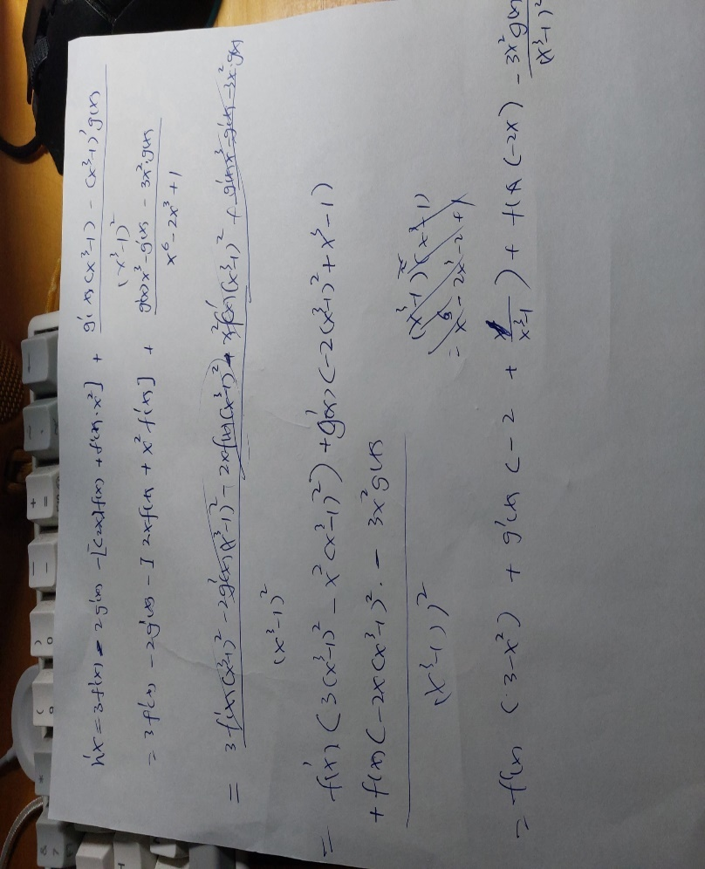

6. Find the values of [x](https://my.uopeople.edu/filter/tex/displaytex.php?texexp=x) at which the graph of [ f (x) = 4x^2  - 3x + 2 ](https://my.uopeople.edu/filter/tex/displaytex.php?texexp=%20f%20%28x%29%20%3D%204x%5E2%20%20-%203x%20%2B%202%20) has a tangent line parallel to the line [y = 2x + 3](https://my.uopeople.edu/filter/tex/displaytex.php?texexp=y%20%3D%202x%20%2B%203). Show detailed work for full credit.

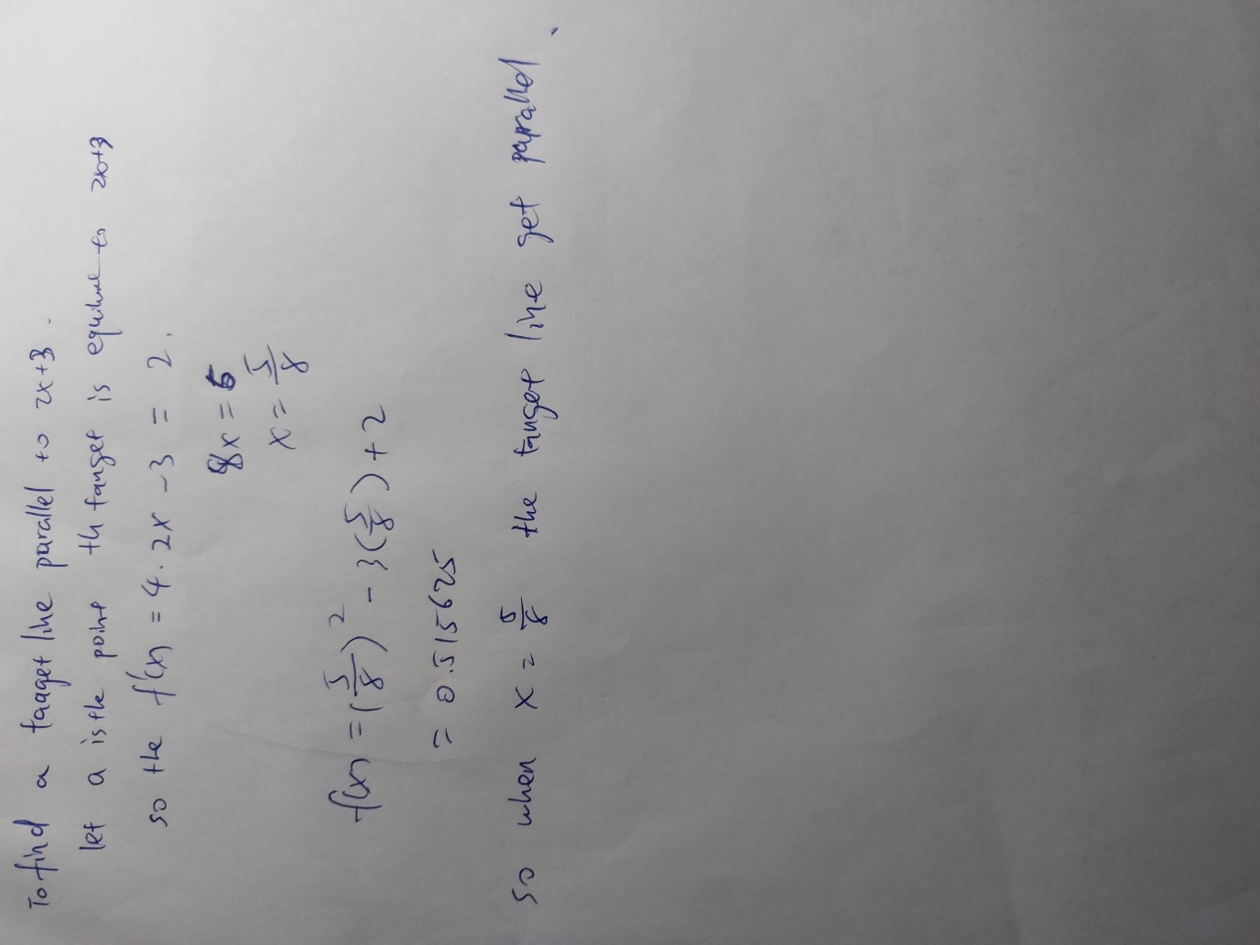

7. Find the equation of a line tangent to the graph of [ f(x)=cot x ](https://my.uopeople.edu/filter/tex/displaytex.php?texexp=%20f%28x%29%3Dcot%20x%20) at [ x= \pi/4  ](https://my.uopeople.edu/filter/tex/displaytex.php?texexp=%20x%3D%20%5Cpi%2F4%20%20). Show all steps to receive full credit.

F(π/4) = 1/tan x = 1

Its passing (π/4,1 )

F’(x)= cot’x = -csc ^2 (x) = -(1/sin(π/4)) = - $√2$

Point slope equation y – y1 = m(x-x1)

Y= - (x- π/4) +1

8. Find the derivative of [ f (x) = 2tan x - 3sec x ](https://my.uopeople.edu/filter/tex/displaytex.php?texexp=%20f%20%28x%29%20%3D%202tan%20x%20-%203sec%20x%20). Show all steps to receive full credit.  
according to substraction rule,

F’(x) = sec^2(x) \* 2 - 3 secxtanx

= 1/cosx^2 -3 \* 1/cosx \* sinx/cosx

= 1/cosx^2 -3 (sinx/cos^2(x))

=(1-3sinx)/cos^2(x)

9. Find the derivative of the following functions (show all the steps for full credit):

i) [ f(x)= \frac{e^x}{x}  ](https://my.uopeople.edu/filter/tex/displaytex.php?texexp=%20f%28x%29%3D%20%5Cfrac%7Be%5Ex%7D%7Bx%7D%20%20)  
ii) [ f(x)=x^2ln x ](https://my.uopeople.edu/filter/tex/displaytex.php?texexp=%20f%28x%29%3Dx%5E2ln%20x%20)

1. according to the quotient rule,

f’(x) = e’xx – 1\*ex/ x^2

as e’x= ex

so f’x = exx -ex/x2

1. according to the product rule,

F’(x) = 2x\*lnx + ln’x \*x2

As ln’x = 1/x

F’(x) = 2xlnx +x

Reference

*3.3 Differentiation Rules - Calculus Volume 1 | OpenStax*. (n.d.). Retrieved September 18, 2022, from https://openstax.org/books/calculus-volume-1/pages/3-3-differentiation-rules